The NoGa “Guppy”
(Genuinely Useful and Practical qrP accessorY)

The “GUPPY” is a semi-break-in antenna switching unit. The name comes from a North Georgia QRP Club building day hosted by Steve Hudson, AA4BW. The club members built a similar circuit, “Manhattan style”, which allowed us to connect our “Transmitter Building Day” transmitters, from Steve’s design to our station receivers. Again, thanks Steve for allowing us to use the GUPPY name.

The circuit board and circuit details are from “W1FB’s QRP Notebook” Published by the ARRL 1991.
The “Guppy” can be used by itself to interface a homebrew transmitter with your station receiver or transceiver. It can also be used in conjunction with the other NoGa kits (the NoGa Wattmeter and the Noga Pig) to create the ultimate QRP Accessory. Combining all three kits into one unit will give:

- Calibrated QRP SWR/Wattmeter with Forward and Reverse meters
- Switchable Dummy Load.
- T/R switch with variable T/R delay (including RX mute contacts)
- Transmit LED
- Power Indicator Guard (including low voltage indicator, over voltage protection, reverse polarity protection)
- K8 CW keyer

See Appendix A, Page 6 for transmitters the Guppy will Key, and modification details for others. Also see www.nogaqrp.org for details of other NoGa kits.

The “Guppy” includes a circuit board and all board mounted components. It also includes a potentiometer to vary the TR delay time and a LED to indicate when the relay is activated. All other off -board components and hook-up wire are to be furnished by the builder.

General

These assembly instructions cover the TR switch only. After the TR switch is completed and tested, suggestions will be given for integrating it with the other kits to provide the Ultimate Qrp Accessory. Please check all parts using the following parts list.

No special tools are required for construction. It is recommended that component part numbers be double checked prior to installation. If in doubt, check resistor values with a multimeter.

The parts list is as follows:

- 12V DPDT relay K1
- .1 uf disc capacitor (104M) C2
- 1 uf electrolytic capacitor C1
- 10uf electrolytic capacitor C4
- 330 uf electrolytic capacitor C3
- 3.9K ohm ¼ watt resistor (org wht red) R1
- 1.5K ohm ¼ watt resistor (brn grn red) R2
- 470 ohm ¼ watt resistor (yel pur brn) R3
- 12K ohm ¼ watt resistor (brn red org) R5
- 1K ohm ¼ watt resistor (brn blk red) R6
- 10K ohm panel mount pot, with knob R4
- (3) 1N914 or 1N4148 D1-D3
- 2N4403 Q1
- 2N4400 or 2N4401 Q2
- Circuit board
- LED

Color codes are for 10% precision. If 5% in kit, measure with an ohm meter.

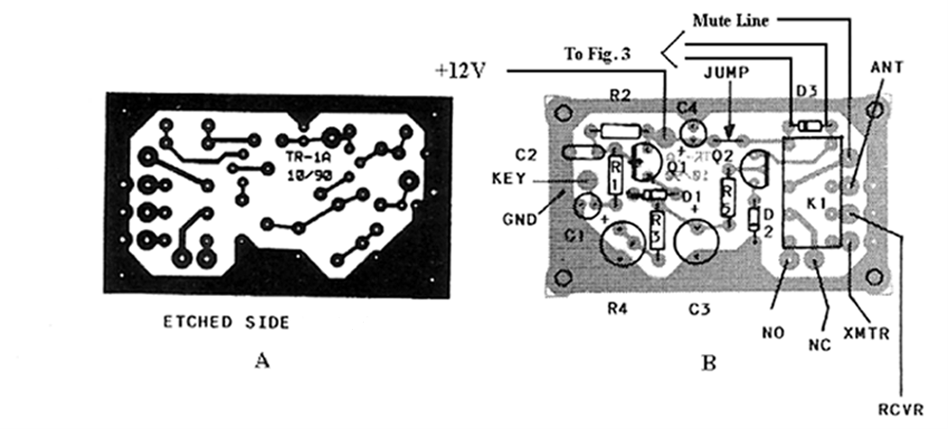
Fig. 1

Assembly:

The circuit board is not marked with component locations, so orient the circuit board per fig. 1 and review the component locations. Be sure to note that all parts are mounted on the non-etched side and soldered on the etched side.

Do not install D3 without reading the special instructions referenced to that part.

Components may be mounted in any order, however the following is recommended.

- Install K1….Be sure to double check the location and leave room for D3. Relay should be flush with top of circuit board

- Install R1, R2, R3 and R5…….Form leads so resistors sit flush on top of the circuit board

- Install C2….Again form the leads so that the capacitor sits flush on the top of the circuit board.

- Install electrolytic capacitors C1, C3 and C4….Form leads if required and make sure that you observe the correct polarity. The short lead is normally the negative lead and should go to ground. Double-check these using fig. 1 and the schematic diagram (fig. 2). Be sure the proper value capacitor is in the proper location and the polarity is correct.

- Install D1 and D2…..Form the leads as required, and be sure to install with the banded (cathode) end as shown in fig. 1.

- Install Q1 the 2N4403 transistor…..Form the leads as required. Be sure that the flat side of the transistor faces as shown in fig. 1.

- Install Q2 the 2N4401 (or 2N4400) transistor…..Form the leads as required. Be sure that the flat side of the transistor faces as shown in fig. 1.

- Install the jumper from near C4 to near Q2, as shown on fig. 1. (this jumper can be formed from one of the cut off component leads)

Note: If you wish to install an LED to indicate when the relay is energized, you must make provisions at this time. The led in series with the R6, will be installed parallel to D3. It is recommended that D3 be mounted approximately 1/8 inch above the circuit board in order to solder hook up wire on both sides of D3 and run this wire to LED/R6 as shown in fig. 3. Alternately the hook-up wire could be tacked on the bottom side of the circuit board.

- Install D3…..Be sure to install the banded (cathode) end as shown in fig. 1. Be sure to read the above note

- Connect one length of hook-up wire to the banded (cathode) end of D3, and one piece to the non-banded end.

- Connect the lead closest to the flat edge of the LED to the wire from the non-banded (anode) edge of D3.

- Connect the lead from the banded (cathode) edge of D3 to R6 and then the other side of R6 to the remaining lead of the LED.

A 10K panel mount pot is included with the T/R switch. Its purpose is to vary the T/R delay to suit operating conditions. Optionally, it may be replaced by a board-mounted trimmer. (any value from approximately 10K to 25K should work)

- Install hook-up wire for + 12 volts and ground. (see fig. 1)

- Install hook-up wire for R4. Run one lead from one of the two holes at the end of R3 and the other to ground. See the component outline for R4 on fig. 1. Remember, if you are following recommendations, do not mount R4 to the board, just run the hook-up wire and solder to the appropriate terminations on R4 as shown on the schematic diagram fig. 2. (The ground connection should connect to the center and left terminal of the pot as viewed from the shaft side)

- Solder a length of hook-up wire to the Key connection near C1,C2 (see fig. 1)

Check all components for proper location and orientation. Check the etched side to make sure that there are no solder bridges and all components are really soldered.

Testing:

- Turn R4 fully counter clockwise.

- Connect +12 volts and ground and look for smoke!

- If no smoke, connect one lead of your ohmmeter to the ANT relay connection and the other to the XMTR relay connection. There should be no continuity.

- Ground the KEY lead. The relay should now have energized and you should read a short between the ANT and the XMTR relay connections. The LED should light. Un-grounding the KEY lead should cause the connection to open and the LED should go out.

- Perform the same test between the MUTE line and the NO (normally open) relay connections. When the relay is energized, the MUTE/NO should be shorted.

- Try adjusting R4 while momentarily grounding the KEY lead and see how the relay dropout delay can be lengthened and shortened.

Briefly touching the KEY lead to ground should keep the relay energized and the LED lit for an amount of time determined by the setting of R4. In actual use, set the delay so that the relay will stay energized during normal pauses in sending CW, just like you would adjust the VOX on a transmitter.

Congratulations you now have a working NoGa Guppy!

You will need to decide how to connect the “mute; NO; NC” relay contacts to suit your situation. If using a Drake receiver or similar there is a mute connection that requires a normally closed relay connection. Other people may desire to just ground the receive antenna connection on transmit by connecting the mute to ground and the NO connection to the receive antenna connection.

For those people who need to Key +12 volts to a transmitter without a built in keying circuit, the circuit in Appendix A may be installed in the transmitter. Alternately it may be built into the GUPPY using the connections shown in fig 2.

Fig. 2

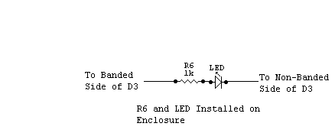

Fig. 3

The Ultimate “GUPPY”

The GUPPY can be integrated with the other NoGa kits to make the ultimate QRP accessory.

The following diagram is just an example of how to wire all 3 kits into one “Genuinely Useful Practical qrP accessorY”. Please pay attention to the diagram of K1B on Fig. 2. Several possibilities exist here, such as, opening the receiver audio on transmit or grounding the receiver antenna on transmit etc.

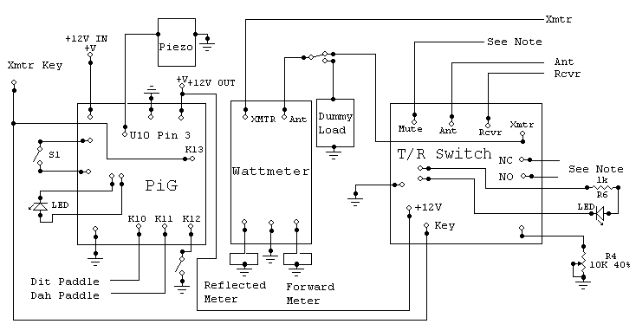

Appendix A

The Guppy circuit will key transmitters with a built in keying circuit where the key line is grounded on key down. It will not key a transmitter where the key interrupts the +12 supply line (such as a Tuna-Tin 2), without adding a keying circuit similar to the one described in an article by Mike Boatright, KO4WX in the October 2000 issue of QRP Quarterly.

He describes a simple method of adding a switching transistor to a transmitter using a keyed +12V line. Complete details are at: http://www.qsl.net/ko4wx/Articles/QRV-Oct-2000.pdf and the circuit is shown below. The 2N2907 shown, is rated at 600 ma. Maximum.

A parts kit for this circuit called the “Guppette” is available from NoGa.

The circuit may be built on a small (1/2” X 5/8”) piece of copper clad board. Use a Dremel tool or other means to cut away the copper clad, dividing the board into 5 sections as shown. (Remove the copper only, do not cut completely through the board) Use a VOM to make sure that none of the sections are shorted together, and tin the pads before attempting to solder the components to the board. Cut and bend the component leads as required to fit in the space available, use particular care with the 2N2907 leads. Stand all components approx 1/8 inch above the board and solder. Mount resistors vertically.

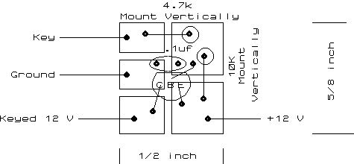

Top View of Board
(components mounted and soldered to the top of the board)

